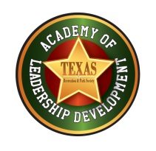
TRAPS Academy of Leadership Development
Vision: TRAPS Academy of Leadership Development will build a community of Parks and Recreation professionals committed to effective leadership, while engaging in a culture of life-long learning, creative thinking, and achieving the highest level of respect and recognition.
TIMELINES 2019-2020
- APPLICATIONS (odd year)
  - Review Task Force Selected … August 15th
  - Announcement and Applications available … September 1st
  - Applications due to TRAPS … October 4th

- REVIEW & SELECTION PROCESS (odd year)
  - Application Packets reviewed , scores tabulated & selections made … October 30
  - Selected cohorts notified … approximately November10th
  - Press Release Announcement … mid- November
  - Profiles, photos and fee collected … December 15th

- COHORT COMMITMENT (even year)
  - 12 month period … even numbered year (Institute even year to Institute odd year); attendance required at all events
  - Attend Institute 2020 (Galveston) … initial orientation (3 hours)
  - Training Blocks …two days in April, May, September, October, & November … $200 commitment fee
  - “Walk the Halls … Parks Day at the Capitol” … January or February of Legislative Year (odd)
  - Option to attend TRAPS Leadership Retreat …day before/after Walk the Halls
  - Attend 2021 Institute (Frisco) … official graduation & recognition @ General Session

