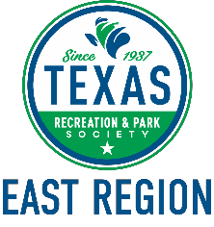

October 15, 2020 MEETING AGENDA
11am Virtual

- Call to Order
- Approval of September 17, 2020 meeting minutes
- Executive Committee Report
  - ER Director – Megan Mainer
  - At-Large Regional Representative – Kevin Browne
  - Secretary/Treasurer/Finance & Development – Elizabeth Anderson
- New Business
  - Discussion and possible action regarding the ER Strategic Plan Objectives.
  - Discussion regarding updated MOGO.
  - Discussion regarding the East Region Workshop in 2021.
  - Discussion regarding ER Maintenance Rodeo deadline.
  - Discussion regarding ER Golf Tournament deadline.
  - Discussion regarding ER annual Awards deadline.
  - Discussion regarding Lunch and Learn in December.

- Region & State Committee Reports (Chair and Past Chair reporting)
- Affiliated Agency Reports (GGCPARDA, TAAF, TPPC, NRPA, TML)
- Announcements
- Adjournment

